Experiment 1 Name: **Pratik Pujari**

Roll no: 20203000**54**

Batch: Comps **C** Batch

**Aim:**

To design webpages using HTML, CSS, and JavaScript.

**Requirements**:

HTML5, CSS3, JavaScript, Bootstrap4, Font Awesome Icons, Visual Studio IDE.

**Problem Statement:**

Twstudy is a social media platform that offers learning courses for all ages and also has an option to register as an instructor. The website fully responsive because of the bootstrap classes working on mobile devices as well as desktops.

* Home page of the website contains all the course info, course details and instructor join option.
* The course page consist of course shown in tab bar view and its details in form of cards. Course details page shows a specific course in details with expansion tiles.
* Log in and sign up page uses Javascript to show the information in alert form.
* Contact Page has a Smtp message email system that collects users data and send the message to the developer’s Gmail account

**What is HTML?**

HTML is actually shorthand for Hypertext Markup Language. It is the language of Web pages that tells a browser how to display certain elements, such as text and images through the use of codes and symbols. HTML is the standard when it comes to creating Web pages. The World Wide Web Consortium, or W3C recommends it. Being such, most browsers implement HTML to help display Web pages more or less uniformly.

**Structure of an HTML page**

HTML is very simple and it is logical. A browser would start reading an HTML page from the top going down, from left going right. It does follow a basic structure. First, you have to declare that the document is an HTML document. You can do this by using the

<html> tag. Then there are the two other sections called the <html> and <body> of your document. The <head> is where you put in all the information you want to include about your document. The <bod> is basically the content of your HTML document.

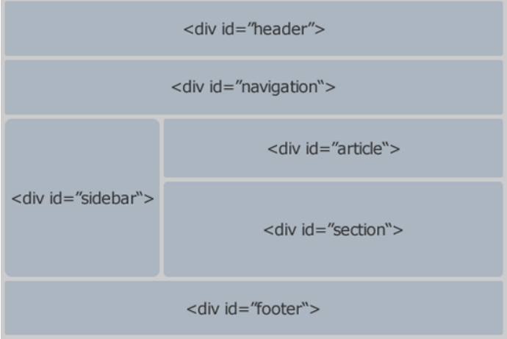

**Some Commonly Used HTML Tags Include:**

<a> ­ which shows a hyperlink

<b>­ which displays boldfaced text

<br> ­ which enters a line break into paragraphs

<div>­ which introduces a section of the document

<em>­ which shows emphasis

<h1>, <h2>, <h3>,through <h6>­ display HTML headings

<hr>­ which inserts a horizontal rule

<p>­ which introduces a paragraph

<table>­ which introduces a table

**What is Css?**

Cascading style sheets or CSS controls how a Web site would appear. There are many ways of styling a particular Web page, but CSS is the one recommended by the World Wide Web Consortium. Using CSS can help you separate the content from the styling. What this means is that you spend less time in maintaining the overall look of your site. If you need to change how a certain element looks, you do not have go through each and every page to do so; you only need to tweak your CSS.

There are three distinct ways to link cascading stylesheets to your HTML documents:

1. Use an external style sheet and refer to it in the HTML document by using the *<link>* element or *@import* rule.

You can use the following code to do this:

*<link rel="stylesheet" type="text/css" href="/style.css">*

Place this code in the <head> section of your page. Additionally, you can use the @import rule for your stylesheet:

*<style type="text/css">*

*@import url(/style.css);*

*</style>*

1. Use an inline style sheet that is introduced by the style attribute.
2. Use a separate but internal style sheet, introduced by the style tag. This must be placed in the *<head>* section of your Web page. Use the following syntax:

*<style type="text/css">*

*(list of CSS rules here)*

*</style>*

Selector

This is the HTML element name at the start of the ruleset. It defines the element(s) to be styled (in this example, <p> elements). To style a different element, change the selector.

Declaration

This is a single rule like color: red;. It specifies which of the element's properties you want to style.

Properties

These are ways in which you can style an HTML element. (In this example, color is a property of the <p> elements.) In CSS, you choose which properties you want to affect in the rule.

Property value

To the right of the property—after the colon—there is the **property value**. This chooses one out of many possible appearances for a given property. (For example, there are many color values in addition to red.)

CSS layout is mostly based on the *box model.* Each box taking up space on your page has properties like:

* padding, the space around the content. In the example below, it is the space around the paragraph text.
* border, the solid line that is just outside the padding.
* margin, the space around the outside of the border.

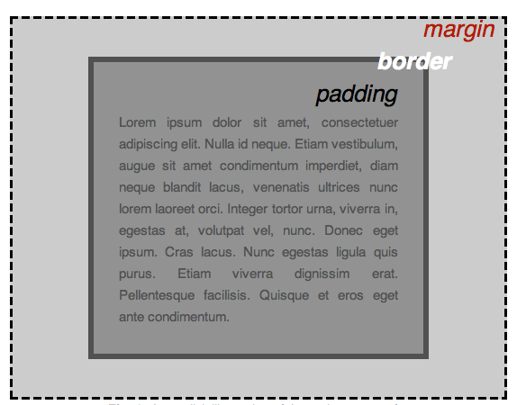

In this section we also use:

* width (of an element).
* background-color, the color behind an element's content and padding.
* color, the color of an element's content (usually text).
* text-shadow sets a drop shadow on the text inside an element.
* display sets the display mode of an element. (keep reading to learn more)

**What is JavaScript?**

JavaScript is a scripting or programming language that allows you to implement complex features on web pages — every time a web page does more than just sit there and display static information for you to look at — displaying timely content updates, interactive maps, animated 2D/3D graphics, scrolling video jukeboxes, etc. — you can bet that JavaScript is probably involved.

* HTML is the markup language that we use to structure and give meaning to our web content, for example defining paragraphs, headings, and data tables, or embedding images and videos in the page.
* CSS is a language of style rules that we use to apply styling to our HTML content, for example setting background colors and fonts, and laying out our content in multiple columns.
* JavaScript is a scripting language that enables you to create dynamically updating content, control multimedia, animate images, and pretty much everything else.

**How do you add JavaScript to your page?**

JavaScript is applied to your HTML page in a similar manner to CSS. Whereas CSS uses <link> elements to apply external stylesheets and <style> elements to apply internal stylesheets to HTML, JavaScript only needs one friend in the world of HTML — the <script> element. Let's learn how this works.

**External JavaScript**

This works great, but what if we wanted to put our JavaScript in an external file? Let's explore this now.

1. First, create a new file in the same directory as your sample HTML file. Call it script.js — make sure it has that .js filename extension, as that's how it is recognized as JavaScript.
2. Replace your current <script> element with the
3. <script src="script.js" defer></script>
4. Save and refresh your browser, and you should see the same thing except the script code it is in a separate file.

IMPLEMENTATION OF WEBSITE

**(Website URL):** [**https://dracula-101.github.io/Html_Css_Project/**](https://dracula-101.github.io/Html_Css_Project/)

**Home Page**

It consist of basic course information, navbar, carousel slider of reviews and a footer.







**Courses Page**

This page consist of all course shown in tabs and also courses preview



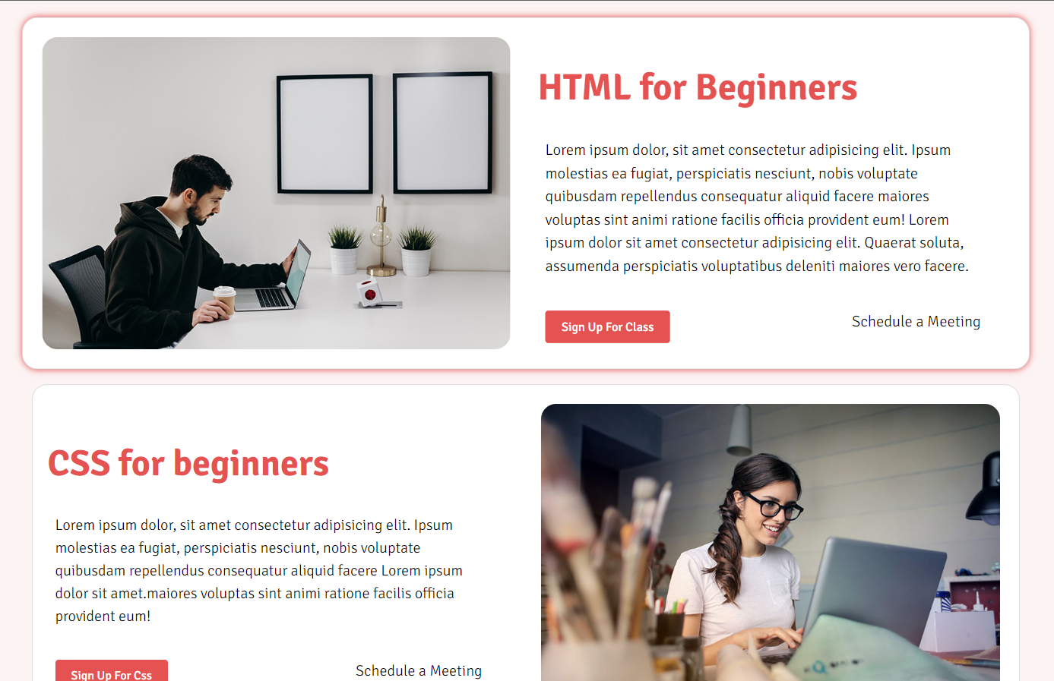

**Course Details Page:**

This page consist of a course in details with expansion tiles and different tabs for different sections

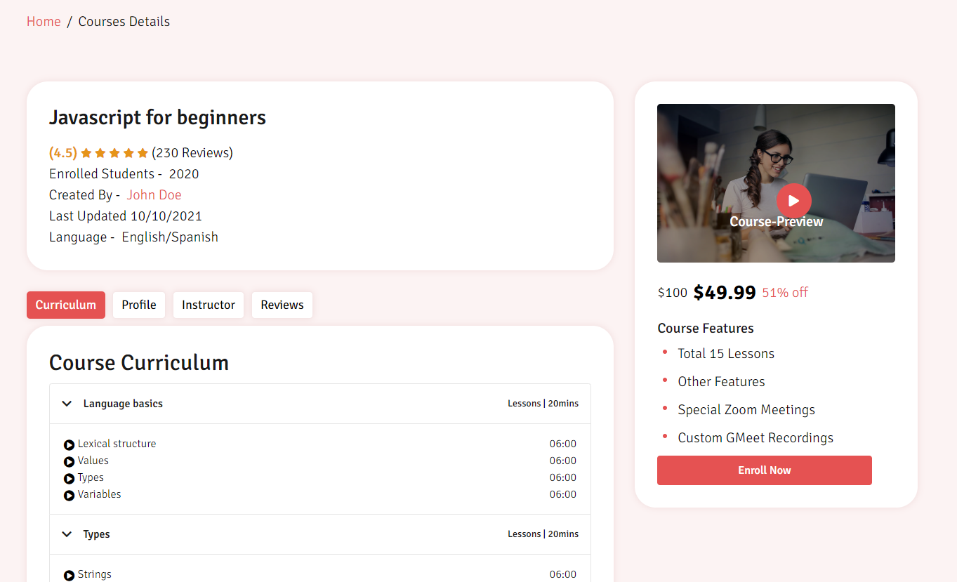

Tab 2 Description Tab 3 Instructor Details

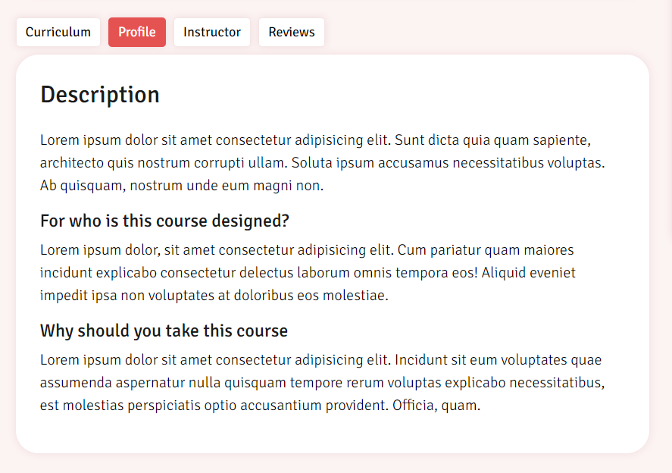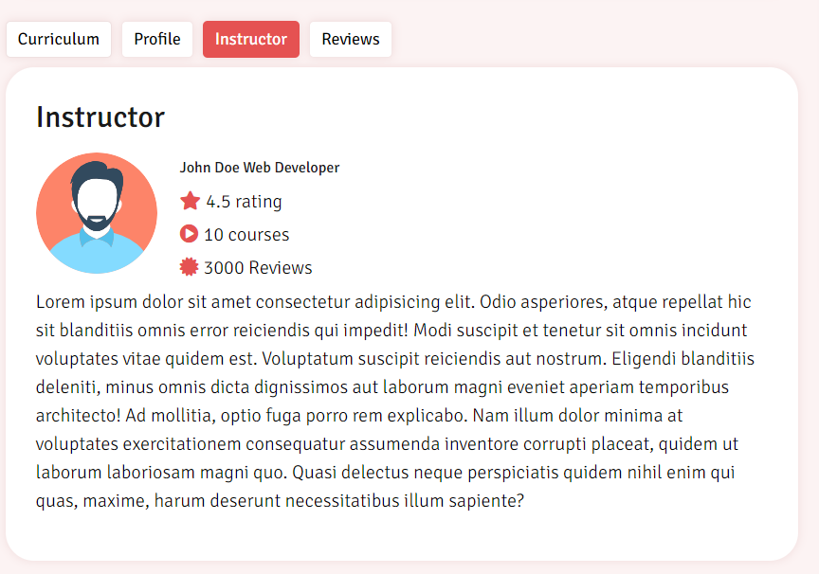

Tab 4 Reviews

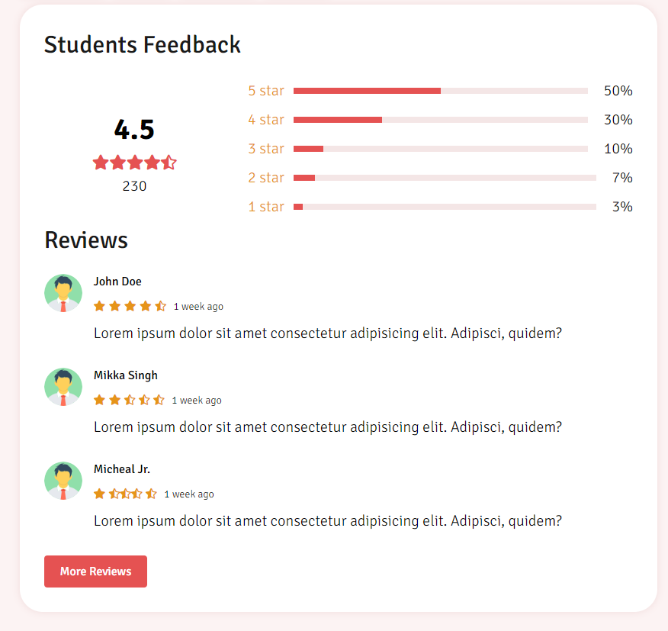

**Login Page**

This pages shows simple login with credentials checking

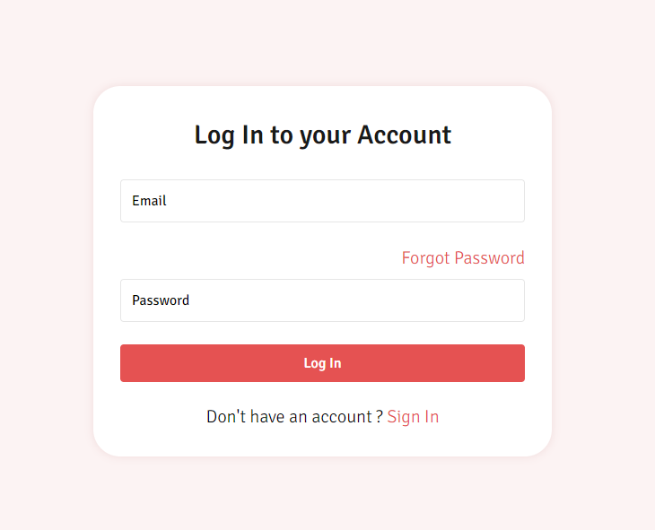

**Sign up Page**

This page shows simple signup with credentials checking using javascript

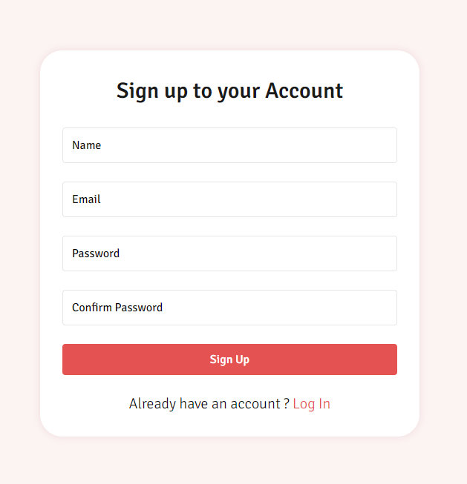

**Contact page**

This page allows the user to send information regarding the website to the dev. This page uses Postmail, a email sender tool which retrives data from the user and sends the Developer’s Gmail Account

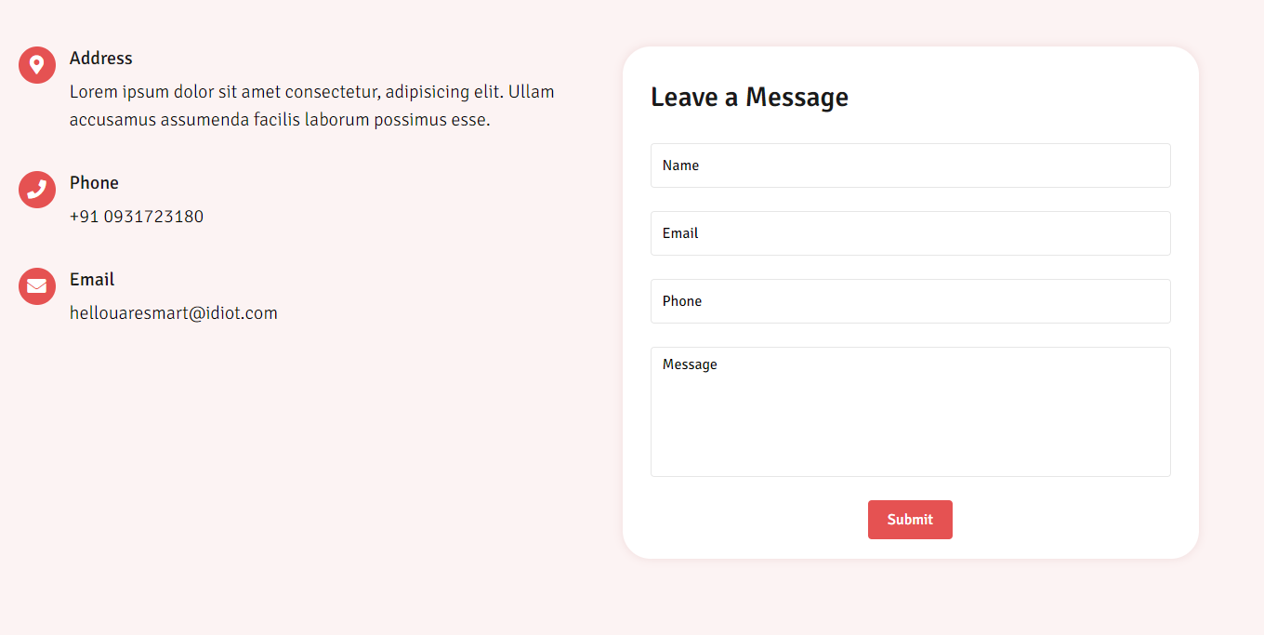

**Conclusion:**

* Used Html/ CSS and JavaScript to make a state webpage.
* In order to make it responsive, Bootstrap classes is used to display the contents correctly in smaller devices
* Email sender tool Postmail is used to send mails regarding suggestion on website
* Font awesome icons are used
* Learnt about good practices in HTML, CSS and JavaScript

**References:**

* <https://www.freecodecamp.org/news/html-basics-for-beginners/>
* <https://html.com/>
* <https://www.khanacademy.org/computing/computer-programming/html-css/intro-to-css/pt/css-basics>
* <https://www.youtube.com/watch?v=D3iEE29ZXRM>
* <https://www.tutorialspoint.com/bootstrap/index.htm>
* <https://getbootstrap.com/docs/5.2/getting-started/introduction/>
* <https://postmail.invotes.com/>